# Adding custom host name to app service.

* Go to app service (ex: pocapp3) from which you want add custom domain name and click on Add hostname.

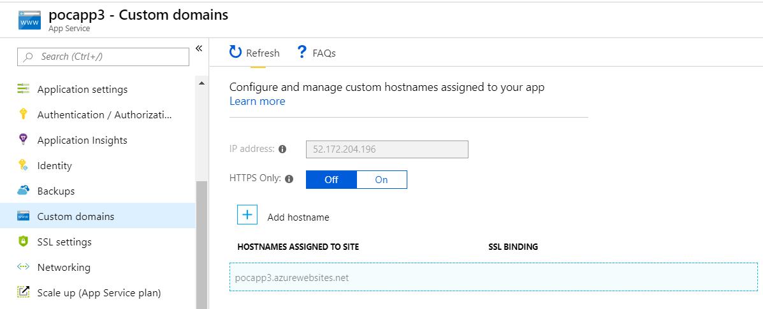

* Enter appropriate host name in following format <Subdomain>.suryahome.co.in as shown below for sample app.

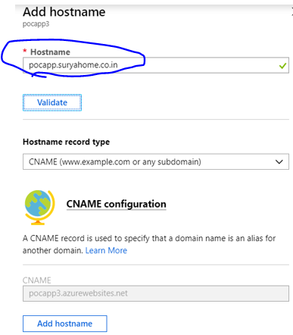

Finally click on Add hostname. You should see success message as shown below.

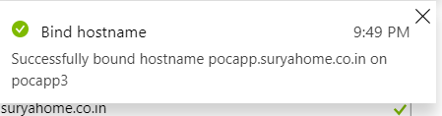

* Now we can access app using the new hostname

